H.T No
Regulations:
A15

Sreenidhi Institute of Science and Technology
(An Autonomous Institution)
Code No: 5EC06 Date: 22-Mar-2021 (FN)

B.Tech IV-Year I- Semester External Examination, March/April - 2021 (Supplementary)
Computer Networks (ECE)

Time: 3 Hours Max.Marks:75

Note: a) No additional answer sheets will be provided.
b) All sub-parts of a question must be answered at one place only, otherwise it will not be valued.
c) Missing data can be assumed suitably.

ANSWER ANY 5 OUT OF 8 QUESTIONS. EACH QUESTION CARRIES 15 MARKS.

Bloom's Cognitive Levels of Learning (BCLL)

Remember | L1 | Apply | L3 | Evaluate | L5
Understand | L2 | Analyze | L4 | Create | L6

 |  |  | BCLL | CO(s) | Marks
1. | a) | Discuss the function of TCP/IP reference model in detail. | L2 | CO1 | [8M]
 | b) | Discuss different network topologies in computer networks. | L2 | CO1 | [7M]
2. | a) | Explain various fields in HDLC protocol. | L1 | CO2 | [8M]
 | b) | List out the various design issues in data link layer. | L1 | CO2 | [7M]
3. | a) | Write about controlled access protocols in MAC. | L3 | CO3 | [8M]
 | b) | Demonstrate how bridge will work with a diagram. | L3 | CO3 | [7M]
4. | a) | computes the correct shortest path distance to 'F' when Dijkstra’s single source shortest path algorithm run from vertex 'A' in the below graph. | L6 | CO4 | [8M]
 | b) | Differentiate between broad cast and multi cast routing. 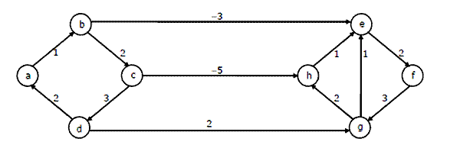 | L3 | CO4 | [7M]
5. | a) | Discuss various congestion prevention principles in networks. | L4 | CO5 | [8M]
 | b) | Draw the format of IPv4 header and discuss various fields. | L4 | CO5 | [7M]
6. | a) | Explain TCP header specifications in detail. | L3 | CO6 | [8M]
 | b) | Write detailed notes on WWW. | L2 | CO6 | [7M]
7. | a) | Demonstrate different kinds of ALOHA protocols in data link layer. | L5 | CO1 | [5M]
 | b) | Write about Ethernet in data link layer. | L5 | CO2 | [5M]
 | c) | Discuss the concept of redundancy in error detection and correction. | L2 | CO3 | [5M]
8. | a) | Draw the flow chart and explain RSA algorithm. | L6 | CO4 | [5M]
 | b) | Discuss UDP protocol with a header format. | L6 | CO5 | [5M]
 | c) | Explain the general principles of congestion. | L3 | CO6 | [5M]
-- 00 -- 00 –

